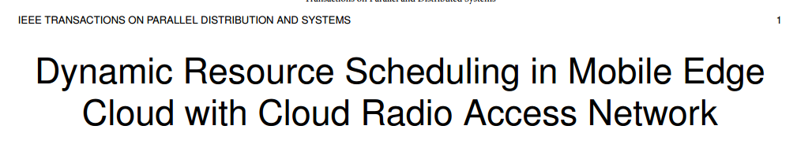

. C-RAN divides the traditional BS into three parts, i.e., remote radio heads (RRHs), baseband unit (BBU) pool, and the fronthaul link

the objective of the mobile system is to maximize the profit of MSP by scheduling the fronthaul links to accept as many requests as possible (i.e., increasing throughput) while minimizing the power consumption of fronthaul links in C-RAN and servers in edge cloud.

(1) how to schedule each fronthaul link by turning to active state for transmitting requests into the BBU pool and sleep state to decline users’ requests for fronthaul power conservation;

(2) how to dispatch the received requests from different users to its corresponding containers in different servers in the edge cloud

3) how to schedule each container to running state1 for requests processing or shutdown state for power conservation.



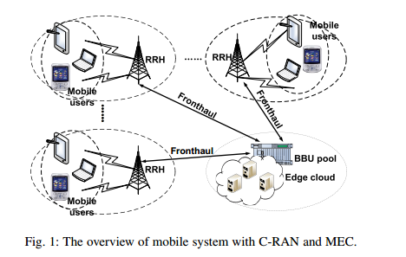

There are M RRHs distributed in different geographic locations, and each RRH i serves and receives job requests from a set of mobile users that are close to this RRH

we model the job requests received by RRH I at time slot t as (T ypeij(t); Sizeij(t)) where T ypeij(t) is the job type and Sizeij(t) is the input data size.

After that, we can model job requests for RRH i at time t as (Ai(t); wi), where Ai(t) denotes the number of job requests with a time average rate λi = EfAi(t)g. wi 2 [wmin; wmax] denotes the number of time slots needed for a job received by RRH i and can be referred to as the workload of the job.

each variable Ai(t) is independent and identically distributed.

In the BBU pool, we implement one of the BBUs as a Dispatcher1 which can receive requests from fronthaul links and route them across several servers in the edge cloud located with the BBU-pool

Edge cloud consists of N servers S ≜ {1; 2; · · · ; N}.

Each server j; 8j 2 S creates containers2 which can process the job requests transmitted from the Dispatcher in the BBU pool



Fronthaul Scheduling: In every time slot t, t = 0; 1; · · · , the mobile system needs to transmit a subset of each user’s job requests Ri(t) into the BBU pool through the fronthaul links

BBU-based Requests Dispatching: the Dispatcher in the BBU pool will route those requests to the

corresponding container hosted in the edge cloud. We assume that the amount of admitted requests Ri(t) are queued in the buffer for each user set i in the BBU pool before dispatching to the corresponding queue for each container in the edge cloud

Cloud Server Scheduling: the last scheduling policy is to schedule each container in time slot t, by stopping the container to shutdown state to keep the requests waiting in this container’s queue, without processing them in the current time slot, or starting the container to running state to process the dispatched user requests that are waiting in this container’s queue









Time average throughput revenue

Time average fronthaul electricity cost

Time average server electricity cost